

Duet Module Interface Specification

For the

**DVX Switcher Dashboard**

**Utility**

**[DVX-2110HD-SP/T, DVX-2150HD-SP/T,**

**DVX-2155HD-SP/T, DVX-3150HD-SP/T,**

**DVX-3155HD-SP/T, DVX-3156HD-SP/T,**

**DVX-2210HD-SP/T, DVX-2250HD-SP/T,**

**DVX-2255HD-SP/T, DVX-3250HD-SP/T,**

**DVX-3255HD-SP/T, DVX-3256HD-SP/T]**

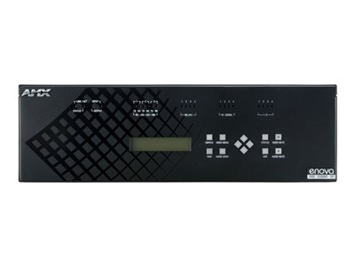

TABLE OF CONTENTS

Overview 3

Implementation 4

Port Mapping 5

Channels 6

Command Control 7

Command Feedback 9

**Revision History**

|  |  |  |  |
| --- | --- | --- | --- |
| **Date** | **Initials** | **Revision Version** | **Comments** |
| 11/16/2020 | IRC | 1.0.0 | Initial Release |
| 1/21/2021 | IRC | 1.0.1 | Enable MultiFormat Video Select  Enable Video Input Name Edit |

## Overview

The DASHBOARD module presents an HTML5 interface for the DVX Switcher device. It is intended for basic operational control of the switcher from a standard web browser (compatibility as listed below).

|  |  |  |  |  |  |  |  |  |  |  |  |
| --- | --- | --- | --- | --- | --- | --- | --- | --- | --- | --- | --- |
| Desktop (Windows & Mac) | | | | | | Android | | | iOS | | |
| Chrome | Firefox | Edge | IE | Opera | Safari | Chrome | Firefox | Opera | Chrome | Firefox | Safari |
|  | Minor  Issues |  |  |  |  |  | Minor  Issues | Minor  Issues |  |  |  |

The module has been tested on DVX-x1xx (master device v4.8.331/switcher device v1.6.76) and DVX-x2xx (master device v1.6.179/switcher device v1.7.81). The interface is presented as a Web Control (shown below) and opens the Dashboard in a new tab. There is a RESTful data update for all synchronous parameters; the switcher device is queried at a 15-second interval while the Dashboard web page is open.

DVX-x1xx:

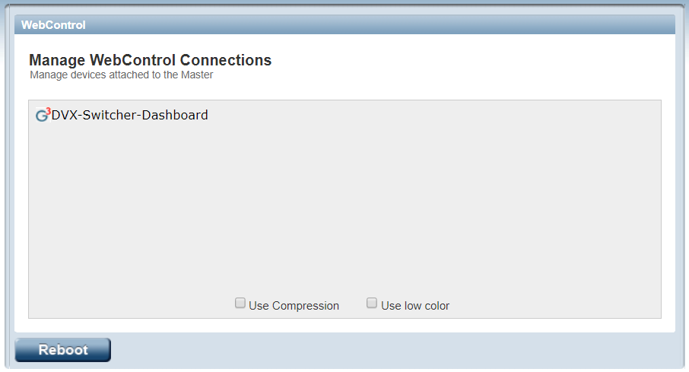

DVX-x2xx:

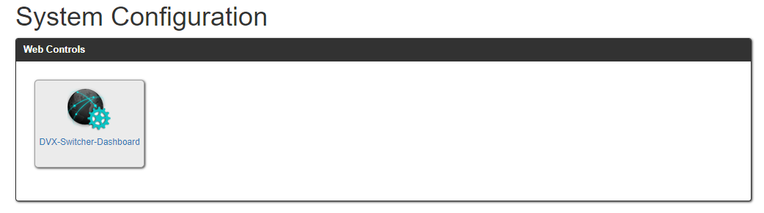

## Implementation

To interface to the module, the programmer must perform the following steps:

1. Define the device ID for the DVX Switcher (5002:1:0) that will be controlled.
2. Define the virtual device ID that the module will use to communicate with the main program. Duet virtual devices use device numbers 41001 - 42000.
3. The Duet DvxSwitcherDashboard_dr1_0_0 module must be included in the program with a DEFINE_MODULE command.

An example of how to do this is shown below.

*(***********************************************************)*

*(* DEVICE NUMBER DEFINITIONS GO BELOW *)*

*(***********************************************************)*

*DEFINE_DEVICE*

*dvSwitcher_1 = 5002:1:0;*

*vdvSwitcher = 41001:1:0;*

*(***********************************************************)*

*(* MODULE DEFINITIONS GO BELOW *)*

*(***********************************************************)*

*DEFINE_MODULE*

*'DvxSwitcherDashboard_dr1_0_0' DvxSwitcherDashboard_dr1_0_0(vdvSwitcher, dvSwitcher_1);*

## Port Mapping

|  |  |  |  |  |
| --- | --- | --- | --- | --- |
| **Virtual Device** | **Channels** | **Levels** | **Control** | **Feedback** |
| 41001:1:0 | Applicable to all Channels | Applicable Levels | Applicable to all Control Commands | Applicable to all Feedback Commands |

## Channels

The channels supported by the DASHBOARD module are listed below. These channels are associated with the virtual device(s).

Note: An ‘*’ indicates an extension to the standard API.

|  |  |
| --- | --- |
| **Channel** | **Description** |
| 251 | ON: Device is Online – used for feedback only  OFF: Device is not Online |
| 252 | ON: Data is Initialized – use for feedback only  OFF: Data is not Initialized |

Table 1 - Virtual Device Channel Events

## Command Control

The commands supported by the DASHBOARD module are listed below.

|  |  |
| --- | --- |
| Command | Description |
| ?DEBUG | Request the state of the debug feature.  ?DEBUG |
| DEBUG-<value> | Set the state of debugging messages in the UI module and the Comm. module.  Note: See Programming Notes section.  <value> : 1 = set only error messages on  2 = set error and warning messages on  3 = set error, warning & info messages on  4 = set all messages on  DEBUG-1 |
| ?PROPERTY-<key> | Get the value of a property <key>. If the value is not initialized, an empty string is returned.  <key> : INPUT.COUNT  <key> : OUTPUT.COUNT  <key> : Has-microphones  ?PROPERTY-Has-microphones |
| PROPERTY-<key>,<value> | Set the value of property <key> to <value>.  <key> : INPUT.COUNT  <value> : Integer <maxInputs>  default: as reported by device 5002:1:0  <key> : OUTPUT.COUNT  <value> : Integer <maxOutputs>  default: as reported by device 5002:1:0  <key> : Has-microphones  <value> : Boolean <hasMicrophones>  default: true  PROPERTY-Has-microphones,false // hide microphone component |
| REINIT | Re-initializes the communication link and data. Re-queries the device for configuration information and re-writes the HTML file. Called automatically when the module first initializes.  REINIT |

Table 2 – Send Command Definitions

## Command Feedback

The commands supported are listed below.

|  |  |
| --- | --- |
| **Command** | Description |
| DEBUG-<value> | Returns the state of debugging messages in the UI module and the Comm. module.  <value> : 1 = set only error messages on  2 = set error and warning messages on  3 = set error, warning and info messages on  4 = set all messages on  DEBUG-1 |
| PROPERTY-<key>,<value> | Feedback on the value of property <key> to <value>.  **Note**: An empty string is returned if the property has no value.  <key> : INPUT.COUNT  <value> : Integer <maxInputs>  default: as reported by device 5002:1:0  <key> : OUTPUT.COUNT  <value> : Integer <maxOutputs>  default: as reported by device 5002:1:0  <key> : Has-microphones  <value> : Boolean <hasMicrophones>  default: true  PROPERTY-Has-microphones,true |

Table 3 - Command Feedback Definitions